Project Planning Phase
Project Planning Template (Product Backlog, Sprint Planning, Stories, Story points)
Date | 06 October 2026
Team ID | Service Now
Project Name | Centralized Medical Diagnostic Center (Skill Wallet)
Maximum Marks | 5 Marks
Product Backlog, Sprint Schedule, and Estimation (4 Marks)
The product backlog and sprint schedule below are prepared for the Centralized Medical Diagnostic Center project. The work is split into six epics and 17 user stories across three sprints, estimated in story points (1, 2, 3, 5).
Sprint | Functional Requirement (Epic) | User Story Number | User Story / Task | Story Points | Priority | Team Members
Sprint-1 | User Management & Access | USN-1 | As a patient, I can register for the application by entering my email, password, and confirming my password. | 2 | High | Member 1
 |  | USN-2 | As a user, I can log into the application by entering my email and password. | 1 | High | Member 1
 |  | USN-3 | As an admin, I can assign roles (patient, technician, doctor, admin) so that each user sees only what they are allowed to. | 3 | High | Member 2
 | Test Booking | USN-4 | As a patient, I can view the list of diagnostic tests and health check-up packages with prices. | 2 | Medium | Member 3
 |  | USN-5 | As a patient, I can book a test by selecting a date and an available time slot. | 5 | High | Member 4
 |  | USN-6 | As a patient, I will receive a booking confirmation by email/SMS once I book a test. | 1 | Medium | Member 3
Sprint-2 | Sample Collection & Tracking | USN-7 | As a technician, I can generate a barcode for each collected sample. | 3 | High | Member 3
 |  | USN-8 | As a technician, I can update the sample status (collected, in process, completed). | 3 | High | Member 3
 |  | USN-9 | As a patient, I can view the current status of my sample. | 2 | Medium | Member 1
 | Test Results & Verification | USN-10 | As a technician, I can enter or upload test results against a sample barcode. | 5 | High | Member 2
 |  | USN-11 | As a doctor, I can review and approve test results before they are released. | 3 | High | Member 4
 |  | USN-12 | As a patient, I will be notified when my report is ready. | 2 | Medium | Member 1
Sprint-3 | Patient Health Record & Report Delivery | USN-13 | As a patient, I can view my previous reports in one centralized health record. | 3 | High | Member 1
 |  | USN-14 | As a patient, I can see trend graphs for repeat tests (for example, blood sugar over time). | 3 | Low | Member 2
 |  | USN-15 | As a patient, I can download my approved report as a PDF. | 2 | High | Member 4
 | Admin Dashboard & Audit | USN-16 | As an admin, I can view a dashboard of bookings, pending samples and turnaround time. | 5 | Medium | Member 3
 |  | USN-17 | As an admin, I can view audit logs of who accessed or changed records. | 3 | Medium | Member 2

Project Tracker, Velocity & Burndown Chart: (4 Marks)
Sprint | Total Story Points | Duration | Sprint Start Date | Sprint End Date (Planned) | Story Points Completed (as on Planned End Date) | Sprint Release Date (Actual)
Sprint-1 | 14 | 6 Days | 12 Oct 2026 | 17 Oct 2026
Sprint-2 | 18 | 6 Days | 19 Oct 2026 | 24 Oct 2026
Sprint-3 | 16 | 6 Days | 26 Oct 2026 | 31 Oct 2026
Total | 48 | 18 Days
Velocity:
The sprint duration is 6 days and the team's velocity is 16 story points per sprint (48 story points over 3 sprints). The team's average velocity (AV) per iteration unit (story points per day) is calculated as follows.
AV = velocity / sprint duration = 16 / 6 ≈ 2.67 story points per day
Burndown Chart:
A burn down chart is a graphical representation of work left to do versus time. It is often used in agile software development methodologies such as Scrum. However, burn down charts can be applied to any project containing measurable progress over time. The chart below shows the planned burndown for this project; the actual line will be added as each sprint is completed.
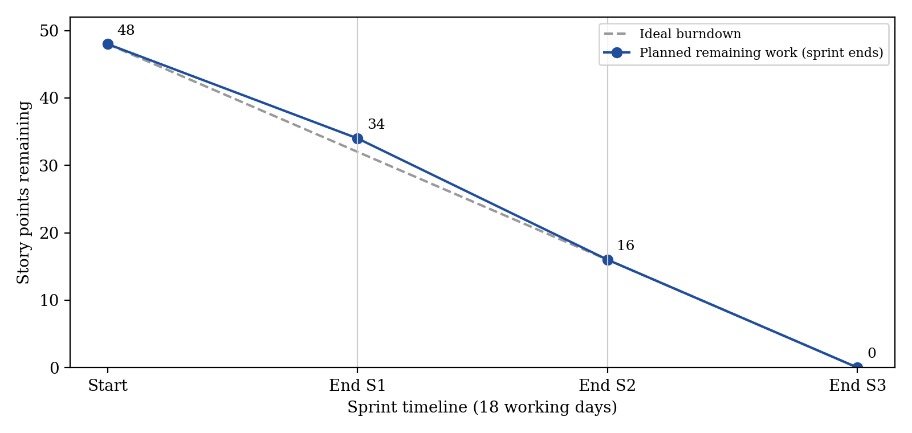
Fig. 1. Planned burndown chart (48 story points over 3 sprints).
Reference:
https://www.atlassian.com/agile/project-management
https://www.atlassian.com/agile/tutorials/how-to-do-scrum-with-jira-software
https://www.atlassian.com/agile/tutorials/epics
https://www.atlassian.com/agile/tutorials/sprints
https://www.atlassian.com/agile/project-management/estimation
https://www.atlassian.com/agile/tutorials/burndown-charts

